**1 Introduction**

A/B testing consists of choosing a metric, reviewing statistics, designing experiments, and analyzing results. A/B testing is a general control/experiment methodology used **online** to test out a new product or a feature. For example, two groups of users act on two versions of websites, their activities will be recorded, some metrics will be computed based on the activities, and the metrics will be used to evaluate the two versions. A variety of things can be tested, from some new features, additions to your UI, different look for you website. Examples:

* Amazon launching personalized recommendations increases the revenue
* visible things: Google testing different shades of blue in the UI
* less visible things: LinkedIn testing displaying top news articles or adding contacts; Google’s search lists and Ads
* unnoticed things: increasing page loading time (~100 ms) decreases sales

However, not for testing out new experiences. (changing features in a UI or on a website is not significant enough for a new experience?) For experience, two questions: what is your baseline and how long to wait the users adapt to the new experiences due to change a version and novelty effect. Or long-term problems vs. A/B testing is short term. Missing features.

**When can we use A/B testing?**

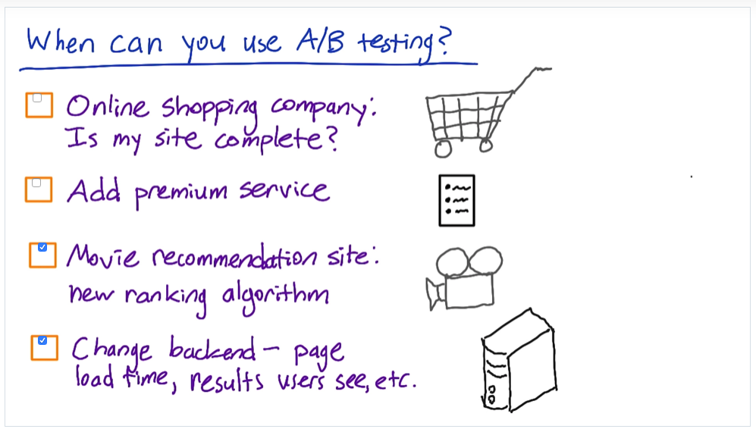

Quiz: When can you use A/B testing?

* Could try specific products but can’t answer in general, ask users
* Can’t fully test if adding premium service is a good business decision because users have to opt into it. No control to compare against. (why no control? Control is no premium process)
* Great example. Clear control and experiment groups. Clear metrics.
* Good if you have the computing power to have two versions of backend.

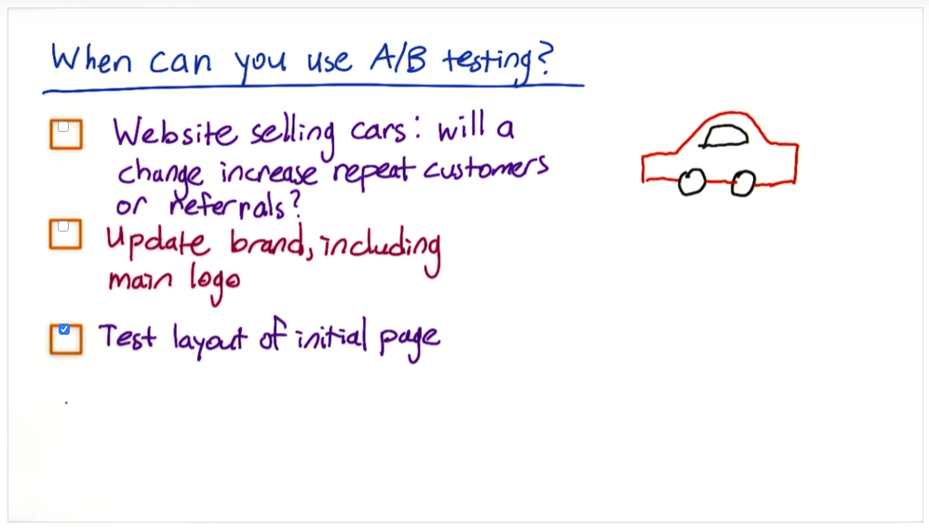

More quiz:

* Too long to test repeat customers and don’t have data for referrals
* Can compare the old and new logo, but surprisingly emotional.
* Great example. Clear control and clear metrics.

When A/B testing cannot be used, what other techniques?

Retrospective analysis with log data -> hypothesis -> design and randomize experiments for a perspective analysis -> A/B testing the hypothesis. User experience research, focus group, surveys, and human evaluation. It is difficult to use A/B testing for new experience.

A/B testing has other names

agriculture, hypothesis testing (clinical trials), consistent response from your control and your experiment group, online A/B testing has lower resolution of users’ information, clinical trials have more detailed information of the participants.

**Overview of an example**

* choose a metric
* review statistics
* design
* analyze

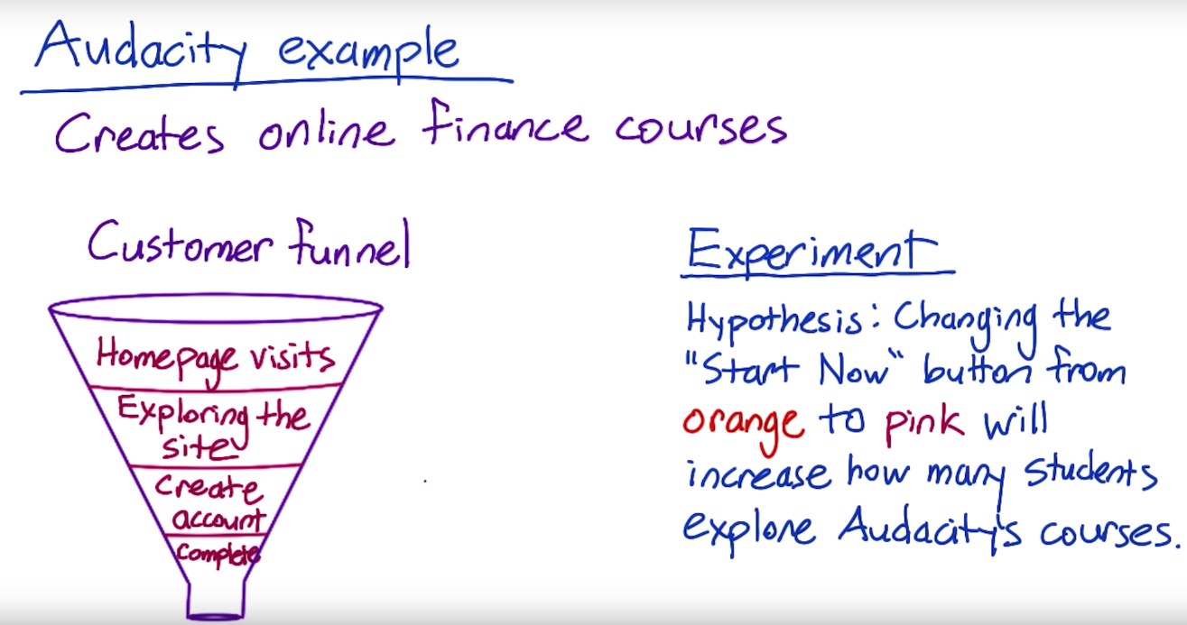

Business example and customer funnel

**Choose a metric**

* Click through rate: # of clicks on one button or link / # of page views containing the button or link.
* Click through probability: # of unique visitors who click a button or link at least once / # of unique visitors who view the page containing the button or link

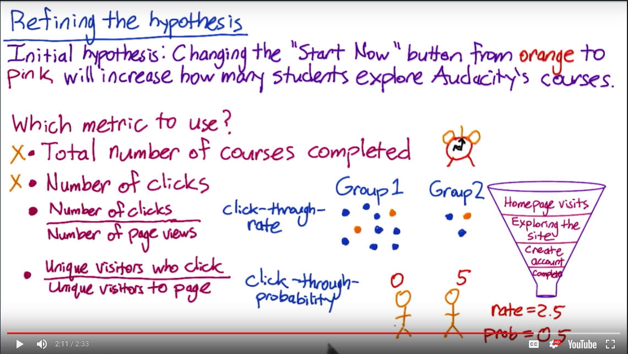

Defining click-through-rate and click-through-probability

The difference is CTR cares about clicks and CTP cares about visitors. A visitor may click and view page multiple times. **In general, a rate is used to measure the usability and a probability is used to measure the impact.**For example, use rate to answer how often a user finds a specific button on a web page with many buttons; use probability to answer how many users progress to the next page. For CTR, engineers modify the website to capture a page view event and a click event. For CTP, need to **further match each page view with all of the child clicks, so that you count, at most, one child click per page view**(this is assuming each pager view comes from a different user). (match each user to a page view?)

**Review statistics (binomial distribution, confidence interval, hypothesis testing)**

**Binomial distribution**

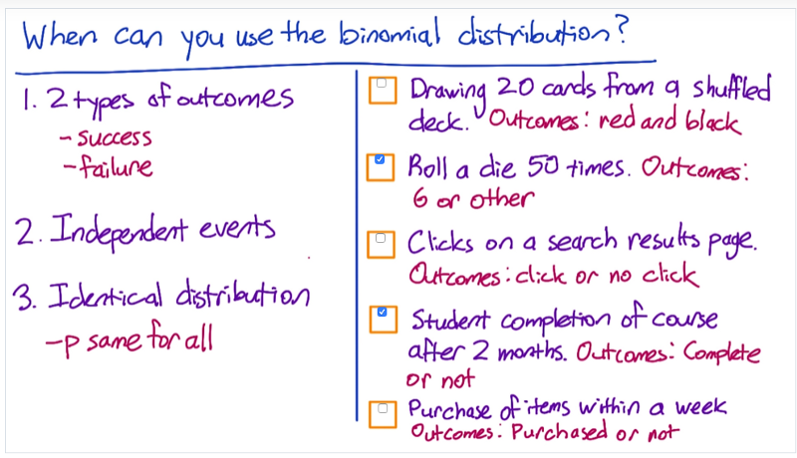

Say we have arandom variable Xn follows a Binomial distribution, Xn ~ b(n, p). We can consider Xn = sum(Xi), where Xi follows Bernoulli distribution, Xi ~ b(1, p). The above picture summarizes some examples when you can or cannot use the binomial distribution.

**Confidence interval**

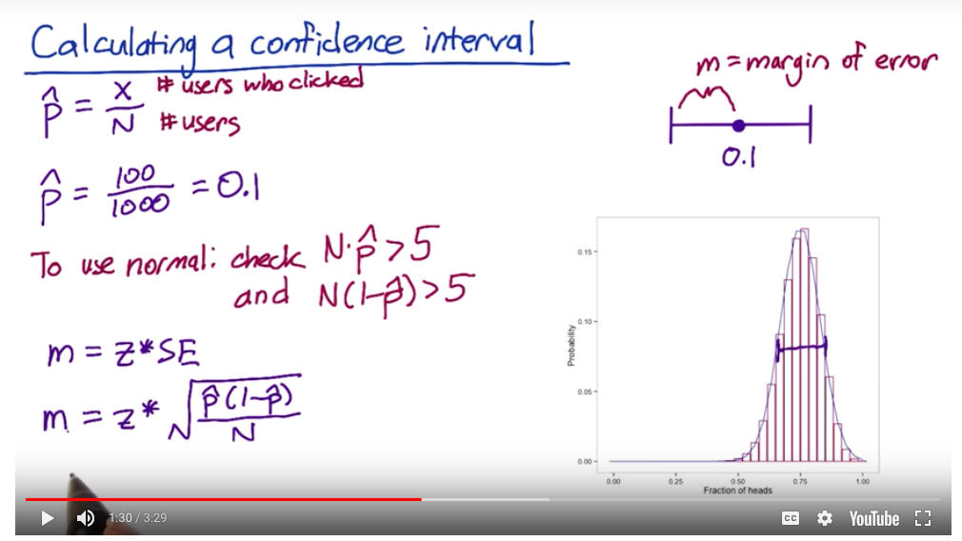

As a binomial distribution converges to normal distribution when n is large, the formula of the margin of error uses the z score from N(0, 1).

This lesson shows how to estimate the confidence interval of the probability p of a binomial distribution: b(n, p). As n increases, a binomial distribution converges into a normal distribution. But how to estimate the parameters of the normal distribution given the binomial distribution. Here is an example, k~ b(n, p) -> N(np, np(1-p)) or p^ ~ b(n, p) -> N(p, p(1-p)/n), where k is the # of successes and p^ is the fraction of success out of n tries with a probability of success p.

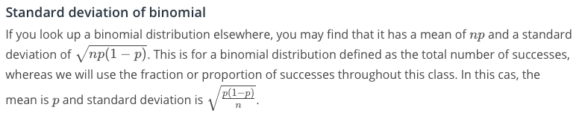

The difference of computing the number of successes (k) and the fraction of successes (p)

Thus, given a sample (100 flips, 40 heads), the sample probability is x, which is 40/100 in this case. We have the following equation:

P(|(x - p)/sqrt(p(1-p)/n)| < u(1-alpha/2)) > 1 - alpha  
After a few conversions...  
x - u(1-alpha/2)*sqrt(x(1 - x)/n) < p < x + u(1-alpha/2)*sqrt(x(1-x)/n)

Recall that binomial distribution can also converge to poisson distribution when n is large and p is small. If np > 5 or n(1-p) > 5, then use normal distribution.

**Hypothesis testing**

P(results due to chance | H0 is True) = p value

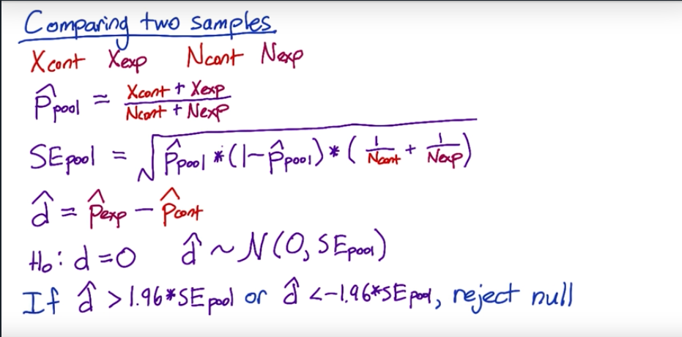

Hypothesis testing for two means

The video shows the hypothesis testing for two means of binomial distribution, similar to two means of normal distribution, using the pooled standard error. Not the hypothesis testing for one mean.

Review the hypothesis testing for two means and large sample

**Practical or Substantive significance**

Hypothesis testing can test whether the result is statistically significant. It essentially tests the **repeatability** of the experiments, which guarantees the change observed in one experiment are repeatable in other experiments with the same set-up. But you also want to know whether the change is interesting from a business perspective. Practical significance means what size of change matters. As a statistician, we care about wha’s substantive in addition to being statistically significant. It will answer whether it is worth the change considering all the costs to make the change.

For example,  
H0: p0 = p1, Ha: p0 <> p1  
The p value of this hypothesis testing is smaller than 0.05, so the difference is statistically significant.   
Then what is the difference, (p1 - p0)? Is it substantive?  
For online cases, if p1 - p0 > 2%, that is already a substantive significance. What if the metric is an absolute number, like the number of clicks or subscriptions?

“So you want to size your experiment appropriately, such that the statistical significance bar is lower the practical significance bar.” ???

**Design**

Sample Size and Power trade-off

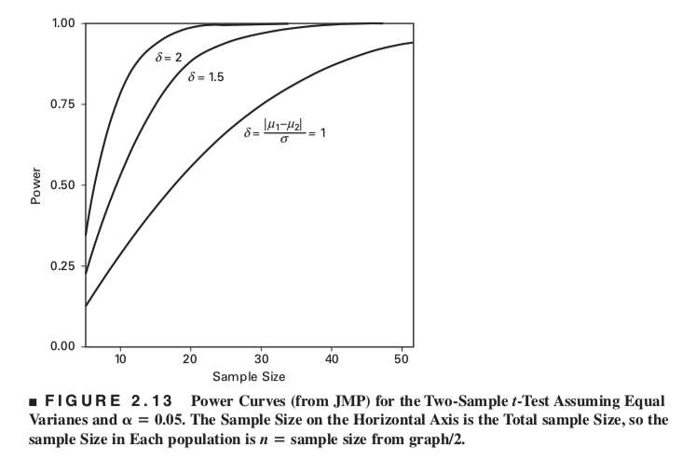

From Design and Analysis of Experiments by Douglas Montgometry, Chapter 2

The above figure clearly shows that given an effect size (the difference of two means divided by the standard deviation), the power increases as the sample size increases. Given a sample size, the power increases as the effect size increases, that is, larger effect size is more easily to be detected. (But in the lesson, the effect size is 2%, the absolute difference of click-through probability ???).

From the lesson, “When we see something interesting, we want to make sure that we have enough power to conclude with high probability that the interesting result is, in fact, statistically significant.” By “interesting result”, it means the difference of two means or the effect size. So we need a probability to tell us the power to detect this difference. The p values shows whether the difference is zero or not. Even though the p value could be very small, we can be 95% confident to say the different is not zero. But the alternative hypothesis doesn’t specify a difference, it is only “not equal”. Thus, given a effect size, the power is the probability to show how significantly we detect this difference.

Why can a larger sample detect a smaller effect size? Because the standard deviation of the sample mean distribution, which is the standard error of the standard deviation of the sample distribution, will reduce as the sample size increases. The sample mean distribution will become narrower, which more easily distinguish two distributions.

The equation — (x-u)/sqrt(variance) basically shows the ratio of difference and variability. If the difference is small, the variability can make it appears “no difference” even thought there is actually a difference. For example, even though there is a 0.02 difference, due to the randomness of sampling, the sample mean distribution may look like the red curve, peak at 0.02 (mean), but with a big variance (wide).

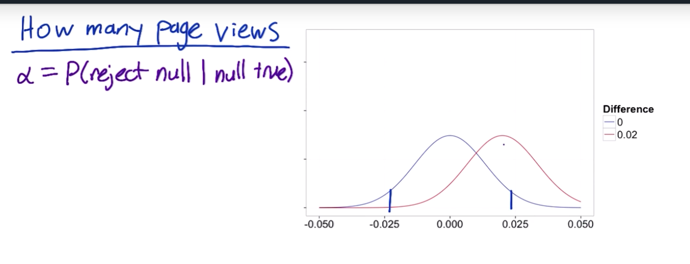

The variance is so big due to sampling a small random sample that the red curve and the blue curve (center at zero) overlap a lot even their means are different by 0.02. In this case, it is very likely the z score lies between the two short blue bars, so the null hypothesis won’t be rejected, then we conclude the difference is zero. If we increase the sample size, the two distributions will become narrower, we have a better chance to reject the null and detect the difference. Given any three of the four parameters including the sample size (n), the significant level (1-alpha), the power (1-beta), the effect size (absolute or relative (u1-u2)/sqrt(variance)), the other one can be computed.

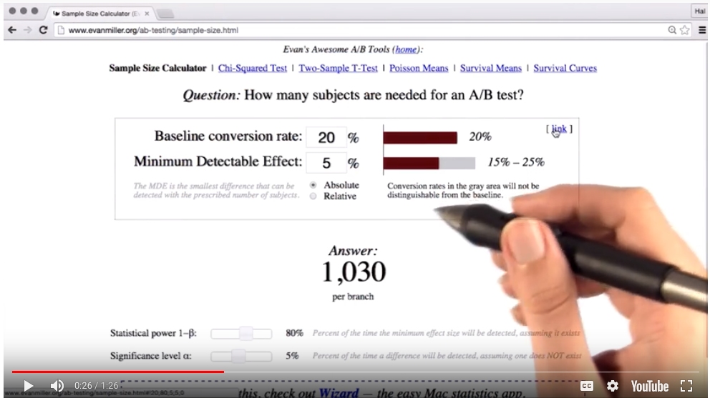

Calculating the sample size given the power, significance level and the effect size

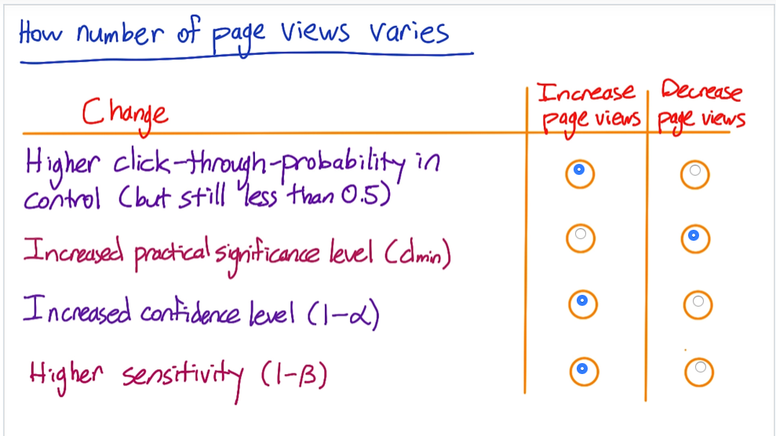

How does the sample size change due to these changes?

Analyze results

Finally, after the sample size is computed, we collect two groups of users and perform A/B testing. Specifically, compute CTP for each group, the difference, the 95% confidence interval of the difference, and decide whether the new feature should be launched.

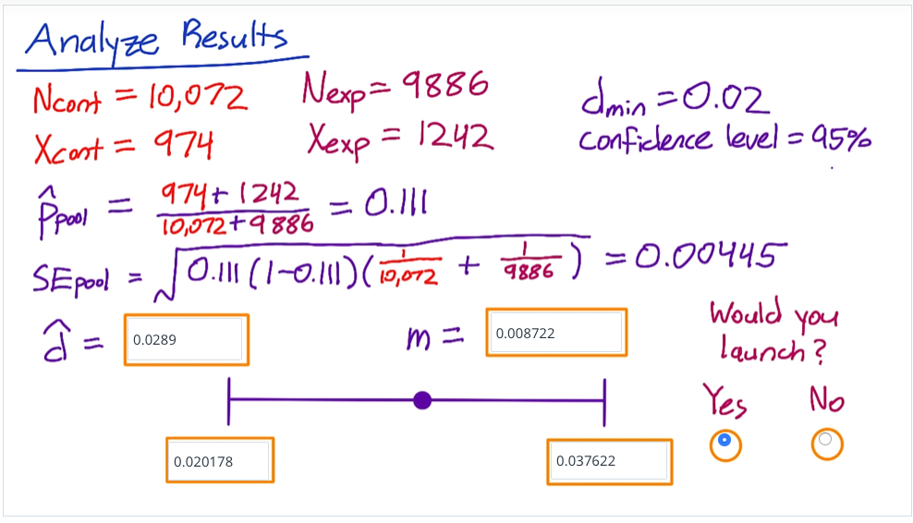

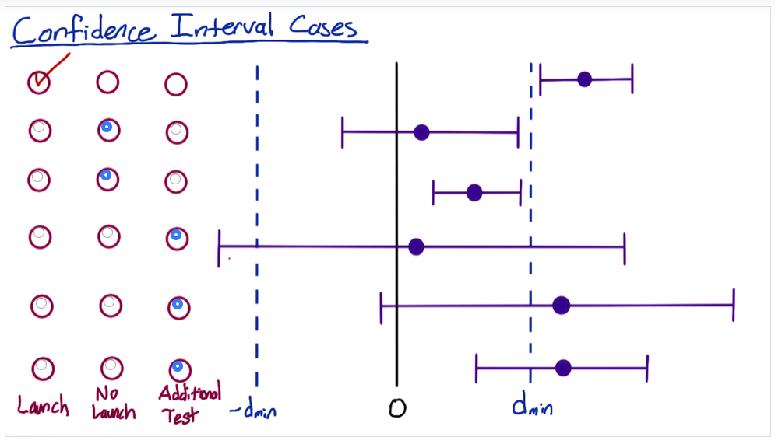

**2 Metrics**

Two types of checks

* ***Invariant checking*:** Metrics that shouldn’t change between your test and control
* ***Evaluation*:** High level business metrics, user experience with the product

How do we go about making a definition of a metric (for sanity checking)?

1. High level concept of metrics (e.g active users, CTR)
2. Details (e.g. how do you define user activity)
3. Take a set of metrics and summarize them into a single metric (e.g. overall evaluation criterion (OEC))

For evaluation, you can choose either one metric or a whole suite of metrics. If you have multiple metric, you can combine them into one metric, such as an objective function, or an Overall Evaluation Criterion (OEC) - a term that Microsoft uses.

The last situation is how generally applicable the metric is. If you are running a suite of A/B tests, it is preferable to have a metric that works across the entire suite.

User funnel indicates a series of steps taken by users through the site. It is called a funnel because every subsequent stage has fewer users than the stage above. Each stage is a metric - total count, rate, and probability (i.e. a unique user progressed down). 

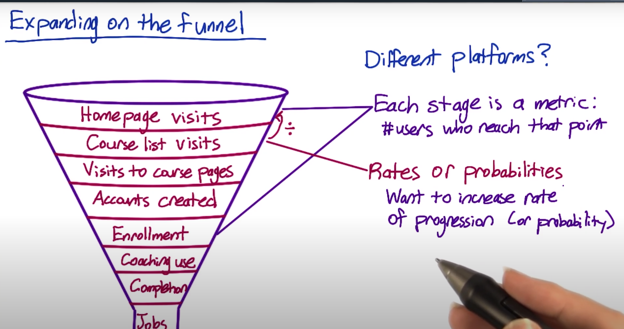

Some metrics may be difficult to measure because

* they don’t have access to data and/or
* it takes too long to collect

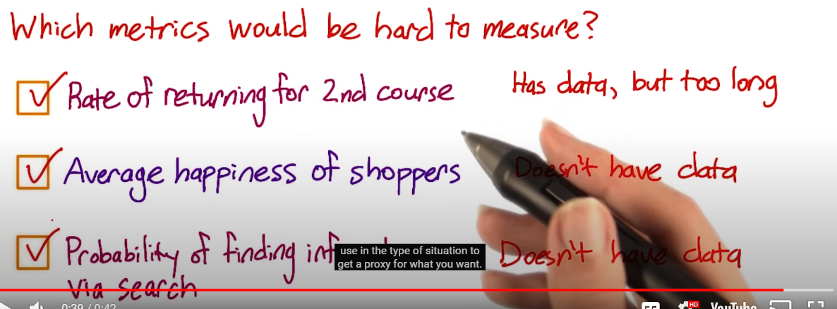

External data can be used. 3 categories of companies that gather data

1. Companies that collect data (e.g. Comscore, Nielsen)
2. Companies that conduct surveys (e.g. Pew)
3. Academic papers

The above can help you benchmark your own metrics against the industry

Internal data can be used as well. You could do

1. Retrospective analysis: Look at historic data to look at changes and see the evaluation
2. Surveys and User experience research: This helps you develop ideas on what you want to research

The problem with these studies is that they show you correlation, and not causation, compared to running an experiment.

Talk to your colleagues about what ideas they think make sense for metrics.

You can gather additional data by

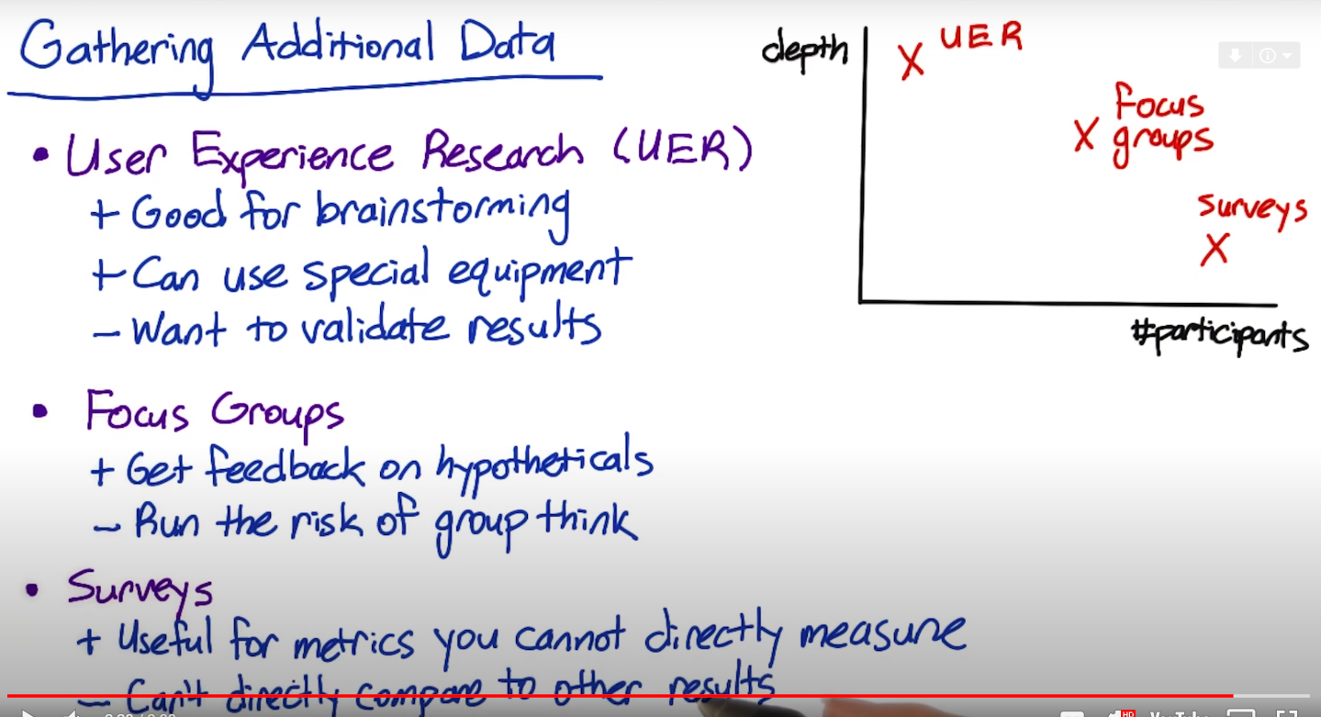

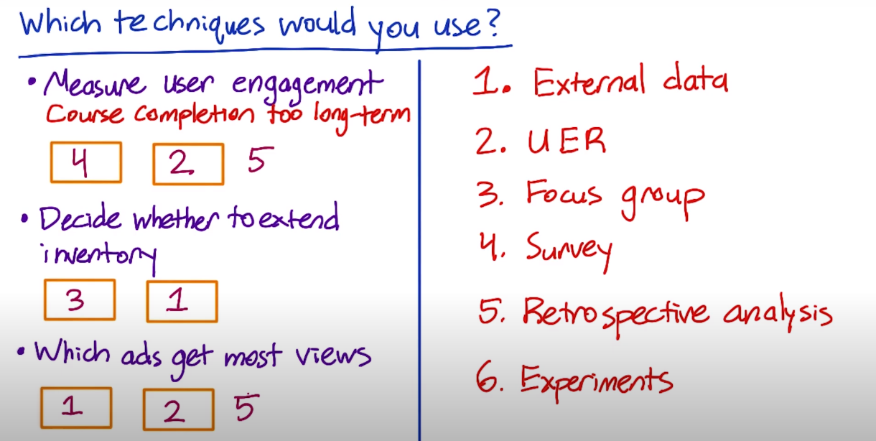

Example of a metric:

High level metric - Click-through probability

1. Def #1 (Cookie probability): For each , number of cookies that click divided by number of cookies
2. Def #2 (Pageview probability): Number of pageviews with a click within divided by number of pageviews
3. Def #3 (Rate): Number of clicks divided by number of pageviews

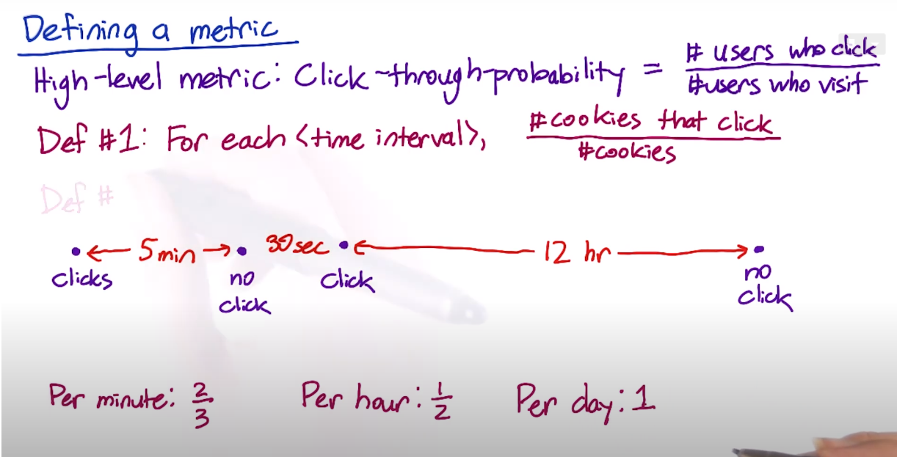

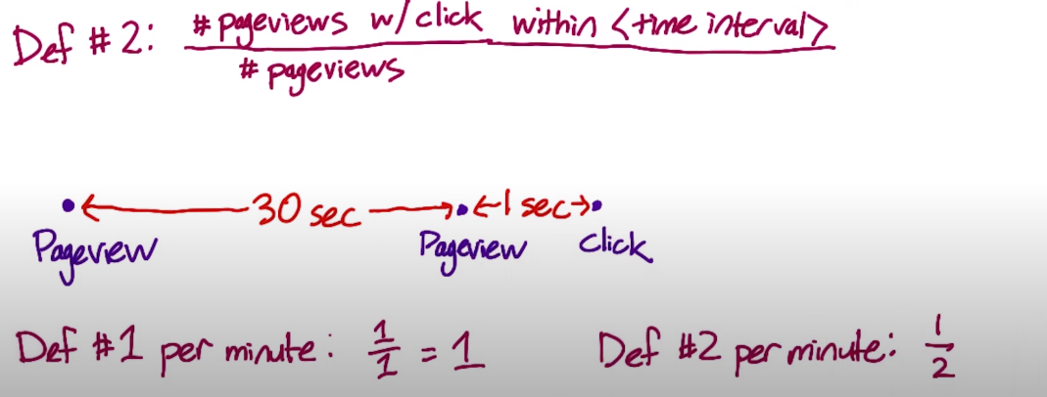

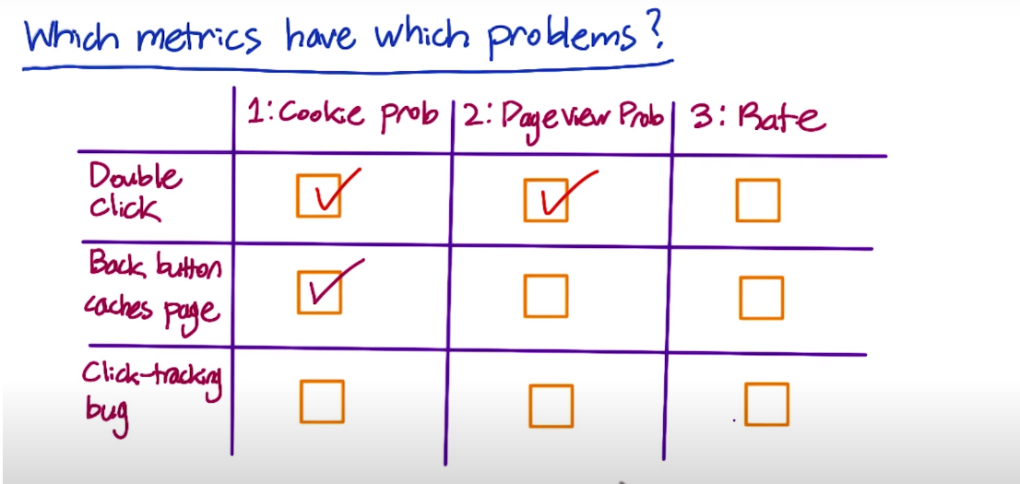

You may have to filter out spam and fraud to de-bias the data. One way to figure out if you are biasing or de-biasing the data by filtering, is to slice your data and then calculate the metric for each slice after filterig. If you are affecting any slide disproportionately, then you may be biasing your data with filtering

To remove any weekly effects when looking say at total active cookies over time, use week-over-week i.e. divide current data by data from a week ago. Alternately, one can use year-over-year.

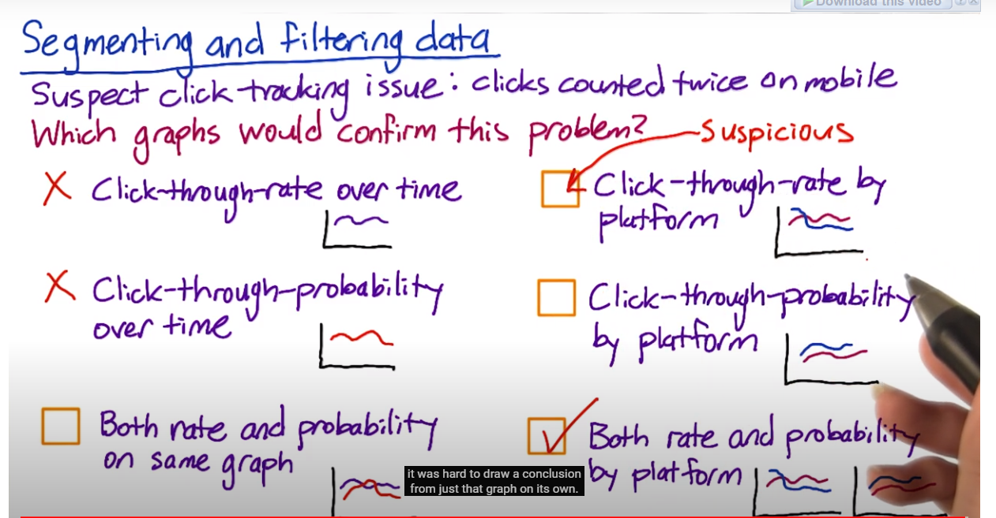

2.1 Characteristics of a metric:

1. *Sensitivity and Robustness*: Whether the metric is sensitive to changes you care about, and is robust to changes you don’t care about (e.g. mean is sensitive to outliers, median is robust but not sensitive to changes to small group of users). This can be measured by using prior experiments to see if the metric moves in a way that intuitively make sense. Another alternative is to do A/A tests to see if the metric picks up any spurious differences
2. *Distribution*: Obtained by doing a distribution on the retrospective data

2.2 Categories of metrics

4 categories of metrics

1. Sums and counts (e.g. # of users who visited a page)
2. Distributional metrics - means, medians, percentiles
3. Probabilities and rates
4. Ratios

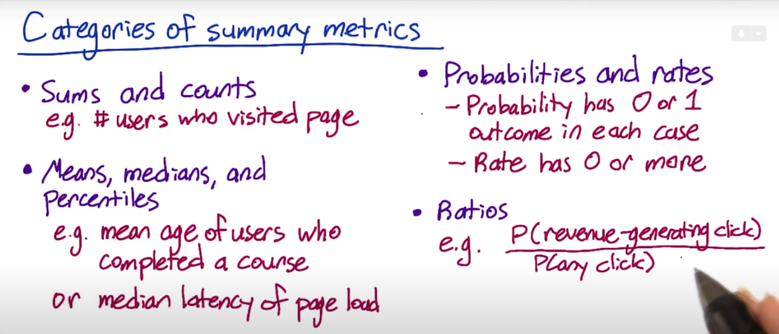

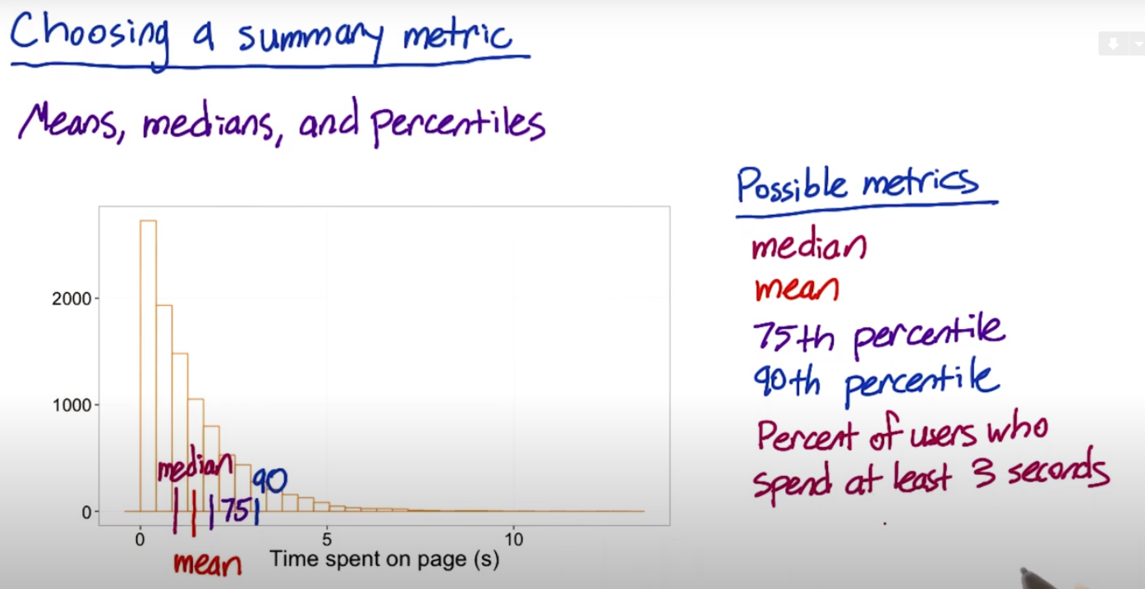

2.3 Absolute vs Relative

The simplest way to compare metrics for test and control is to take a difference.

If you are running a lot of experiments you want to use the relative difference i.e the percentage change. The main advantage of computing the percentage change is that you only have to choose one practical significance boundary to get stability over time. If you are running a lot of experiments over time, your metrics are probably changing over time. Using relative difference helps here by having to use one practical significance boundary rather than change it as the system changes. The main disadvantage is variability, relative differences such as ratios are not as well behaved as absolute differences

2.4 Calculating variability

We want to check the variability of a metric to later determine the sizing of the experiment and to analyze confidence intervals and draw conclusions. If we have a metric that varies a lot, then the practical significance level that we are looking for may not be feasible.

To calculate the confidence interval, you need

* Variance (or standard deviation)
* Distribution



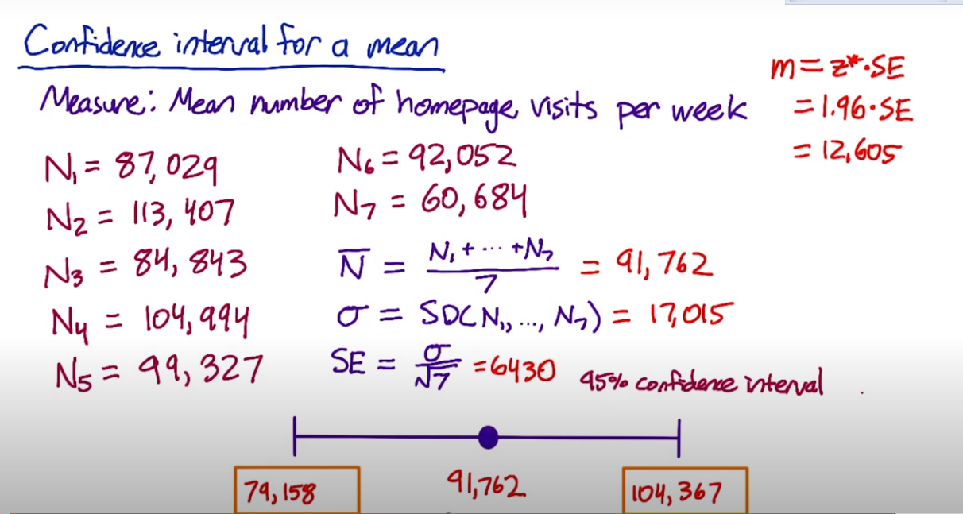

For a binomial distribution, your estimated variance is p(1−p)/Np(1−p)/N. Estimated variance of the mean is σ2/Nσ2/N. If the underlying data is normal, then the median will be normal. But if the underlying data is not normal, the median may not be normal. The mean is typically normally distributed irrespective of the distribution of the underlying data due to Central Limit Theorem. Difference in counts may be normally distributed. The variance of the difference will be the sum of the variances of each of the 2 counts. Rates tend to have a poisson distribution, and the variance for a poisson is just the mean. For ratios of test over control, both the mean and the variance depends on the distribution of the test and control metrics.

e.g.

x <- c(87029, 113407, 84843, 104994, 99327, 92052, 60684)

stder <- sd(x)/sqrt(length(x))

conf95_min = mean(x) -1.96*stder

conf95_max = mean(x) + 1.96*stder

conf95_min

## [1] 79157.54

conf95_max

## [1] 104367

2.5 Non-parametric methods

This is a way to analyze data without making an assumption about the distribution. At Google, it was observed that the analytical estimates of variance was often under-estimated, and therefore they have resorted to use empirical measurements based on A/A test to evaluate variance. If you see a lot of variability in a metric in an A/A test, it is probably too sensitive to be used. Rather than do several multiple A/A tests, one way is to do a large A/A test, and then do bootstrap to generate small groups and test the variability.

With A/A tests, we can

1. Compare result to what you expect (sanity check)
2. Estimate variance empirically and use your assumption about the distribution to calculate confidence
3. Directly estimate confidence interval without making any assumption of the data

In summary, different metrics have different variability. The variability may be high for certain metrics which makes them useless even if they make business or product sense. Computing the variability of a metric is tricky and one needs to take a lot of care.

For a lot of analysts, a majority of the time is spent is validating and choosing a metric compared to actually running the experiment. Being able to standardize the definitions was critical in the test. When measuring latency, are you talking about when the first byte loads and when a last byte loads. Also, for latency, the mean may not change at all. The signals (e.g. slow/fast connections or browsers) causes lumps in the distribution, and no central measure works. One needs to look at the right percentile metric. The key thing is that you are building intuition, you have to understand data, and the business, and work with the engineers to understand how the data is being captured.

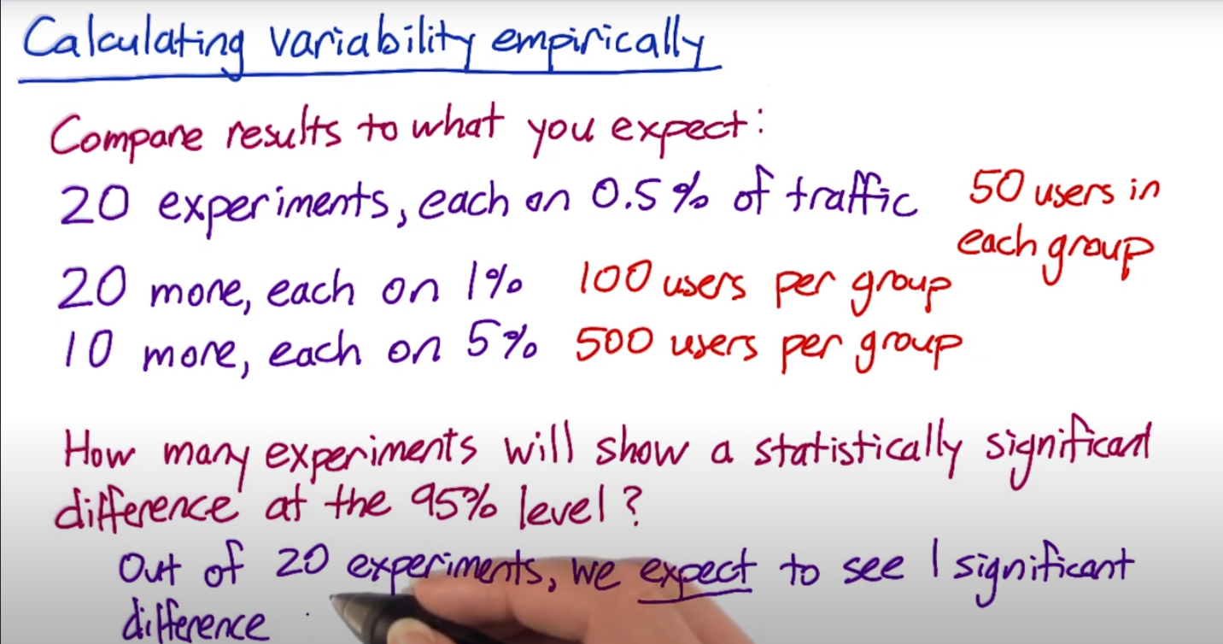

Use A/A tests to

* Compute variance and confidence interval based on the assumption of the distribution (usually normal distribution)
* Directly compute the confidence interval without any assumption of the distribution
* Compare empirical results to analytical results (sanity check)

For example, 20 A/A experiments, 50 users per group in each experiment and one click-through-probability computed based on one experiment from 50 + 50 users. The following table shows 20 experiments (20 rows). Take the first row for example. Based on the clicks and pageviews of 50 users in Group 1 and 2, the CTP is 0.1 and 0.04. The difference is diff=0.1–0.04 = 0.06.

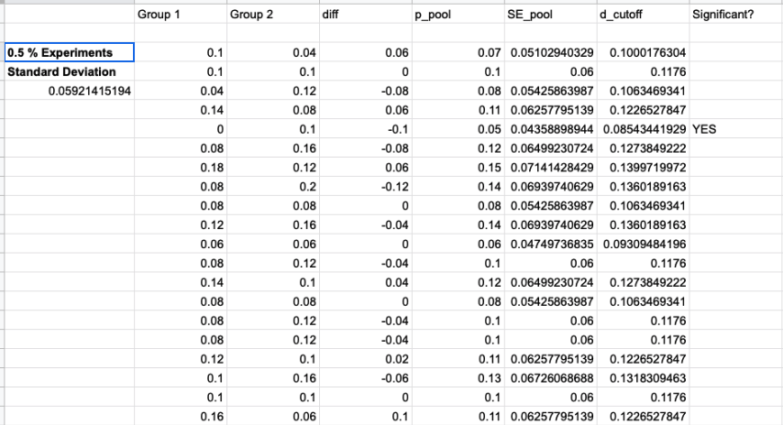

20 experiments (20 rows)

The pooled standard deviation of each experiment is computed based on the analytical formula. **This assumes the distribution of the clicks is a binomial distribution.**???

SE_pooled =

The empirical standard deviation, 0.059, is computed from 20 diff values. **Note that from these 20 experiments, there is only one empirical variance of p_diff but 20 analytical pooled SE.** It is the same for confidence interval. **If the diff is assumed to be normal distribution,** the confidence interval can be computed with SE and z score. Based on the histograms, although it doesn’t look like a normal distribution, it may be due to the small sample size (only 20 or 10 data points to create histograms). Note that when computing the pooled SE for each experiment, **Ncont and Nexp (not the number of experiments)**affect the pooled SE. As N increases, the SE decreases.

margin of error = empirical_SD * z(95%)   
**??? empirical SD not SE  
Need to do SD/# of experiments ???**

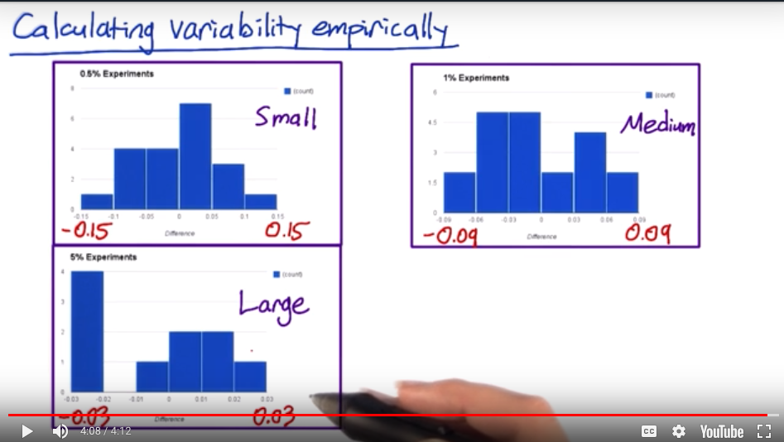

The distribution of 20, 20 and 10 experiments with 0.5%, 1.0% and 5% traffic per group.

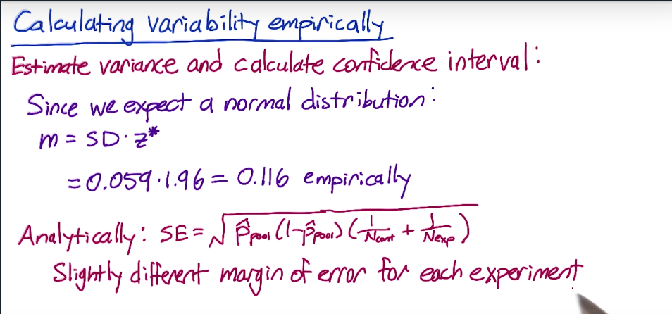

Compare the empirical SD and analytical SE. If assuming a normal distribution, still use the same formula to compute the confidence interval

If the diff is not normal, directly estimate empirical confidence interval, [-0.1, 0.06]. Using the assumption of normal distribution and the empirical variance, the confidence interval is [-0.097, 0.097]. They are somewhat different because there are only 20 experiments (data points). And because of that, we can’t distinguish 95% or 90% confidence interval in this case.

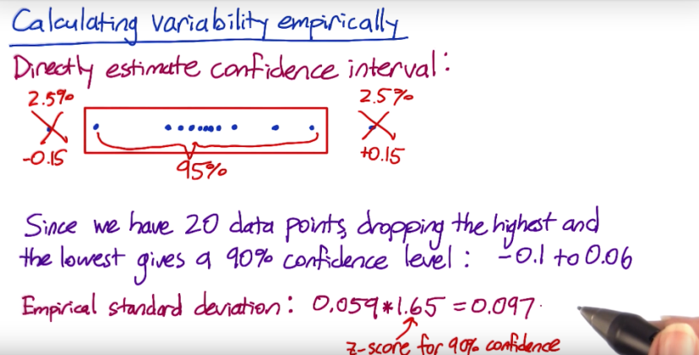

Directly compute empirical confidence interval.

If there is no enough traffic to perform many A/A experiments, bootstrapping (sample with replacement) can be used to simulate the experiments with just two group of users.

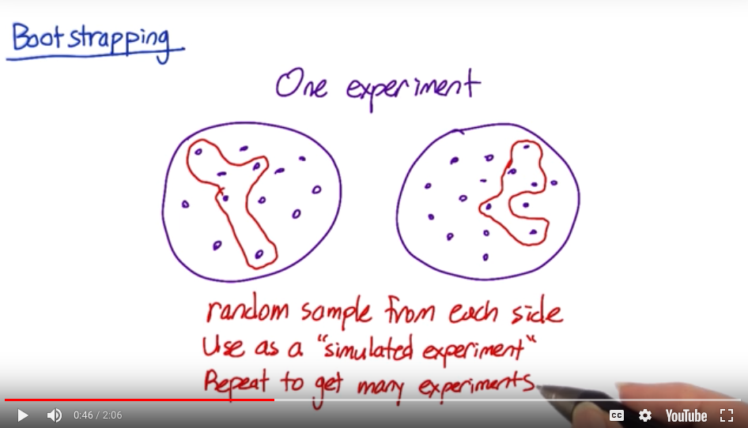

Bootstrapping

## Variability Summary

Choosing metrics is a tricky thing.

* Although some metrics make great sense to the business, they may have large variability so that it won’t show statistical significance for experiments.
* Some metrics have analytical form for variance and confidence interval based on the assumption of the distribution of the metrics.
* If the above metrics are not valid in practice, empirical variance and confidence interval would be computed.

**Step to choose the metrics:**

1. **Establish high level concepts for your metrics**
2. **Go into the details in order to compute the metrics**
3. **How to build intuitions about the metrics and how appropriate it is for different experiment**
4. **Characterize the variability (lack of consistency or fixed pattern) of your metrics**

**3 Designing an Experiment**

* Choose “subject” — units of diversion
* Choose “population” — equivalent population
* Size
* Duration and Exposure

It is an **iterative** process to try out some decisions for unit of diversion and population, see what the implication is on both the size and the duration of the experiment. Depending on the results, we will need to revisit the decisions and iterate.

## Unit of Diversion

Unit of diversion basically answers the question that **“how to assign events to either the control or to the experiment”**. **Even though the metric is computed based on the events (e.g. page view), the unit of diversion decides how these page views appear in the two groups**, randomly or from a certain subset of users. For example, if the unit of diversion is a page view, which is an event-based diversion, each page view will be assigned to one group randomly and the user who viewed the page can be mixed into two groups. If the unit of diversion is user_id based, each user is assigned to two groups. The control group only has page views from user A and the experiment group only has page views from user B.

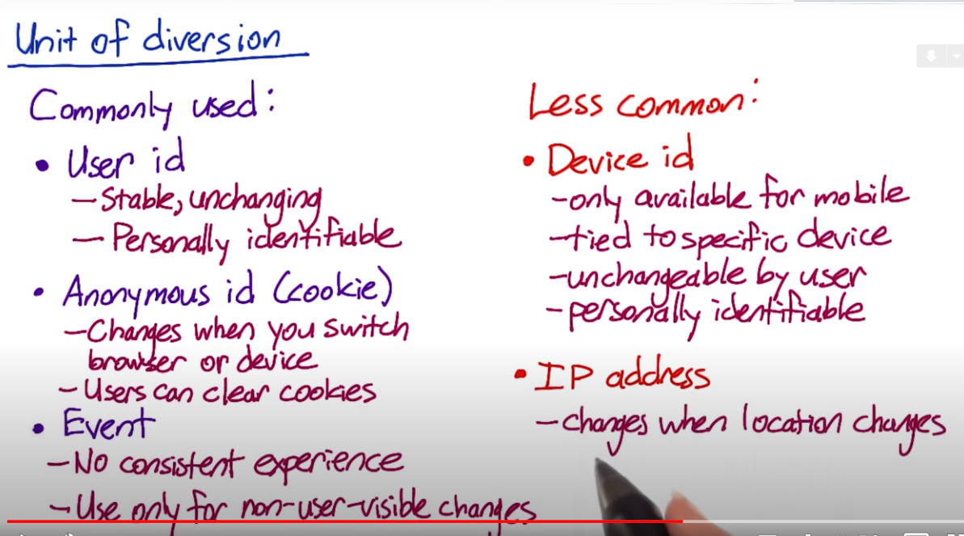

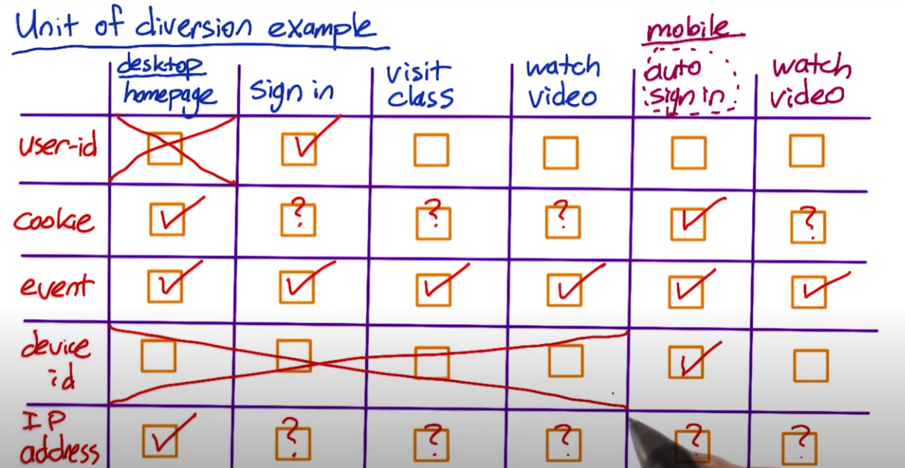

Both user and cookie diversion are **proxies** for users. For the user and cookie based diversions, one group of users are on the A side and the other group of users are on the B side. More precisely, for the user_id based diversion, the **user accounts** are assigned to the control and experiment groups, although multiple users may use the same account. For the cookie_id, the **cookie ids** are assigned to the two groups although the same user may have multiple cookies (devices/browsers). Then from there, the page views are generated from the two groups of accounts or cookie ids. For the event-based diversion, the page views are randomly assigned to the two groups, which may include the same users on both sides. If the metric is CTR, then apparently the page views for the user_id based diversion may have correlations because multiple views may come from the same user. (???)

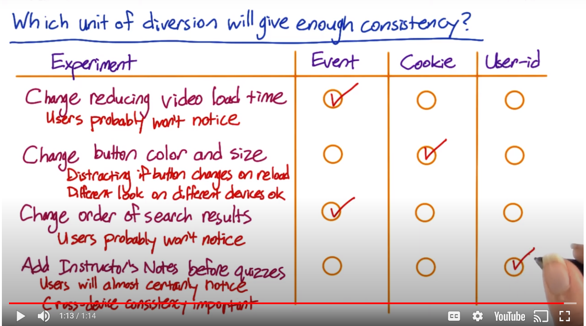

## Unit of Analysis vs. Unit of Diversion

When the unit of analysis is different from the unit of diversion, **the analytical variability may underestimate the empirical variability (empirical > analytical). Because the samples (page views) are assumed to be independent for the analytical form but the page views may have correlations in practice**. Look at the example in the following picture.

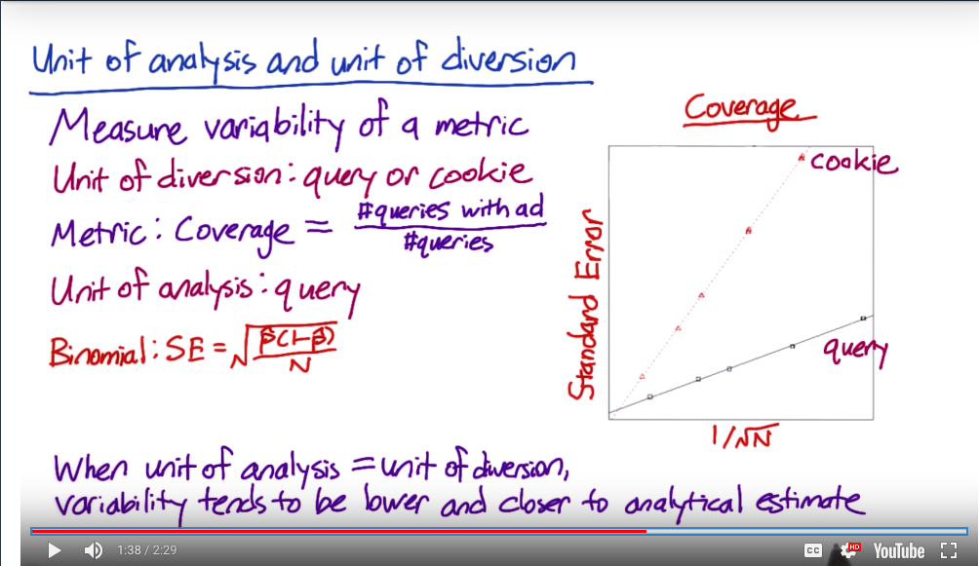

The variability for different unit of diversion based on [this paper](http://static.googleusercontent.com/media/research.google.com/en/us/pubs/archive/36500.pdf)

The above picture shows (1) the SE linearly increases with 1/sqrt(N), which is not surprising; (2) the SE of cookie-based diversion is higher than event-based diversion. Because the queries that come from the same cookies, these queries can be “correlated” (e.g. query something first, then query further from there).

**Questions**about the curve in the [paper](http://static.googleusercontent.com/media/research.google.com/en/us/pubs/archive/36500.pdf)**:** the SE’s are computed from empirical variability assuming the coverage follows binomial distribution? If so, the variance is computed from the coverage (p). For (1), due to the linearity, the variance is almost the same for different samples, the coverage is the same too. For (2), the variance of cookie is higher than that of query, the coverage is higher.

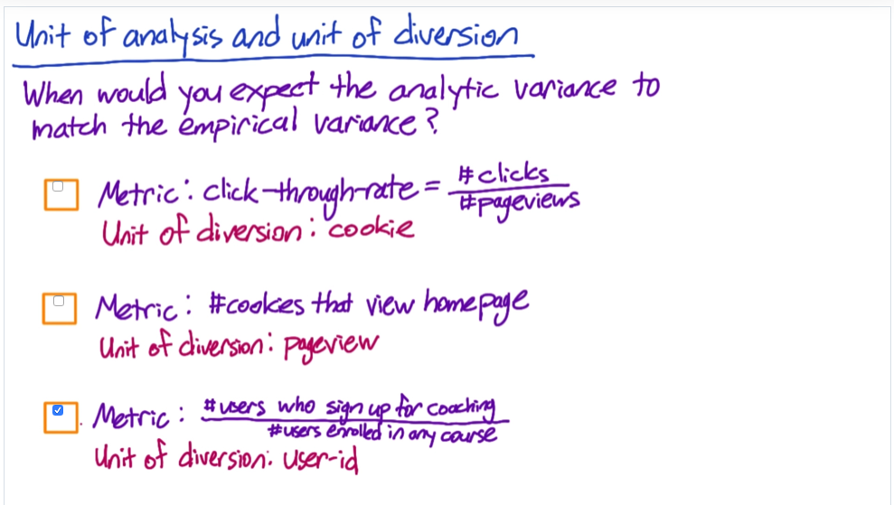

Does the unit of analysis and the unit of diversion match?

For the second question In the above quiz,, the unit of analysis (cookie)is “larger” than the unit of diversion (page view). The metric is not well-defined because the same cookies can be assigned to both groups. To think about a concrete example, make some changes on the homepage : (1) randomly assign cookie ids to Group A (no change) and B (change homepage), cookie m and n are in Group A and B, measure how many cookies (percentage of cookie ids within each group) look at the homepage during a time period; (2) randomly assign page views to the two groups, how to make sure the page w/o go to different groups.

## Choose “population”

* Intra-user experiment: exposing the same user to the feature being on and off over time, analyzing how they behave in different time windows.
* Interleaved experiment: for ranking type of applications, e.g. ranking or preferences, exposing the same user to the A and B side at the same time.
* Inter-user experiment: A/B testing, two groups of users on the A and B side. A refinement is two cohorts of users, which match up the parameters in the two groups.

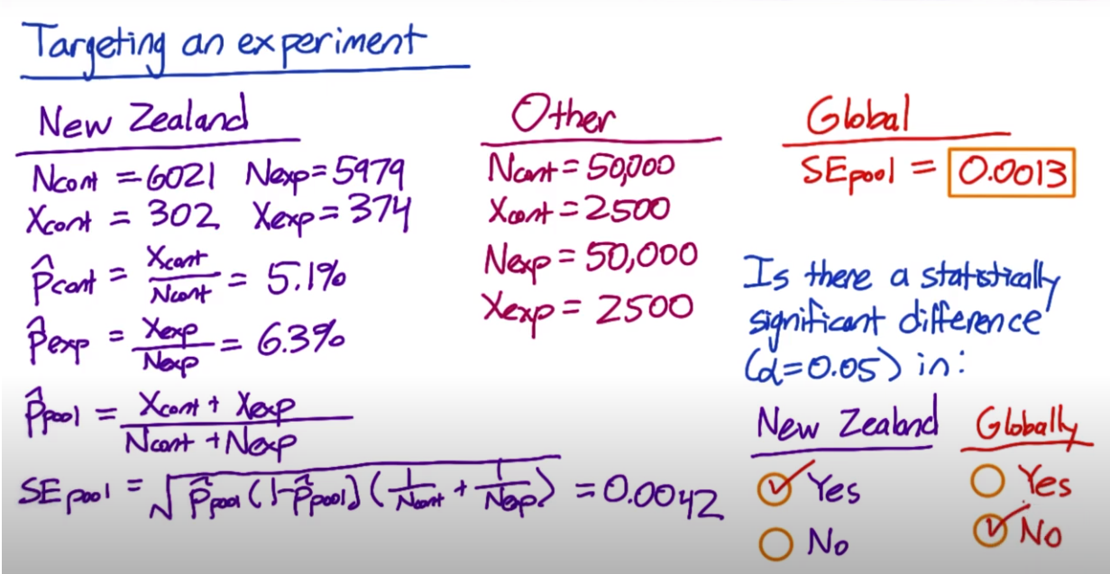

Cohort includes the people who enter the experiment at the same tim. Targeting a cohort from a population can **avoid diluting the effect size** due to targeting unrelated users. It can also reduce the traffic.

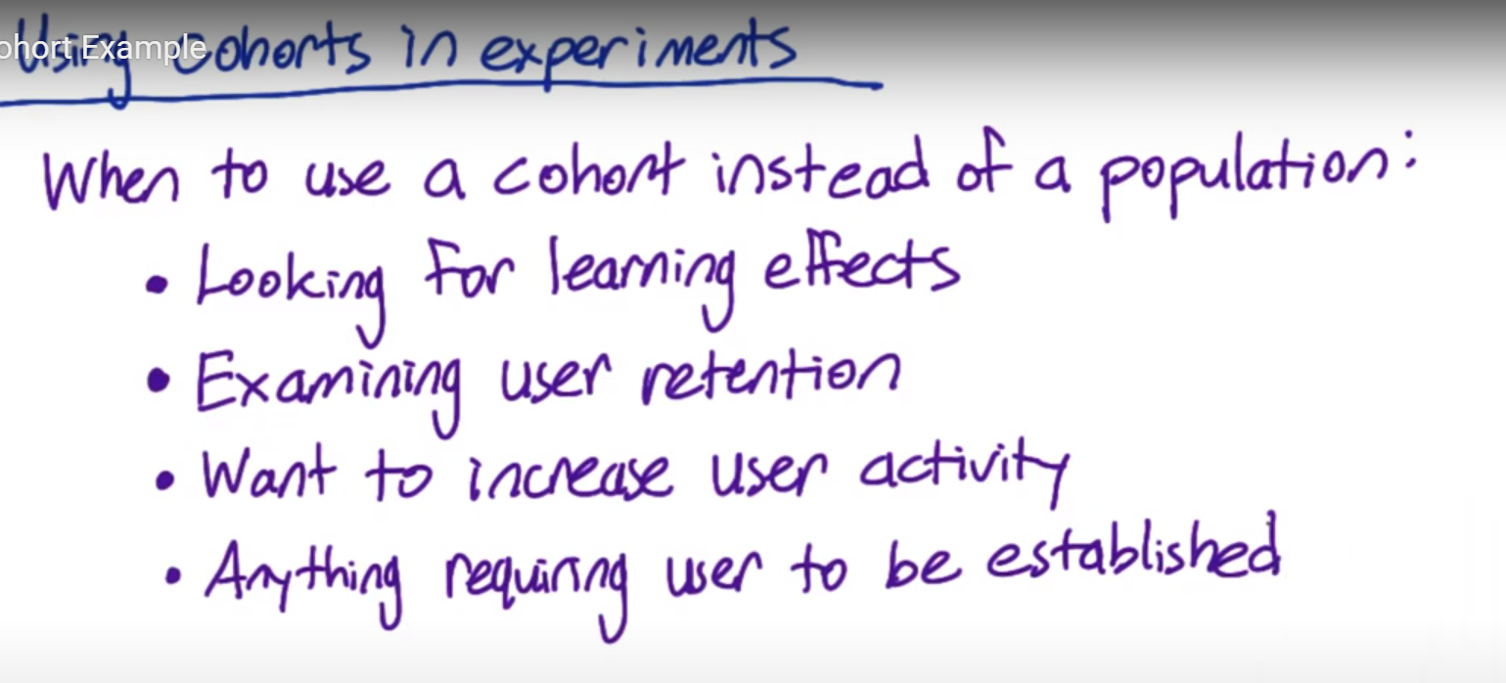

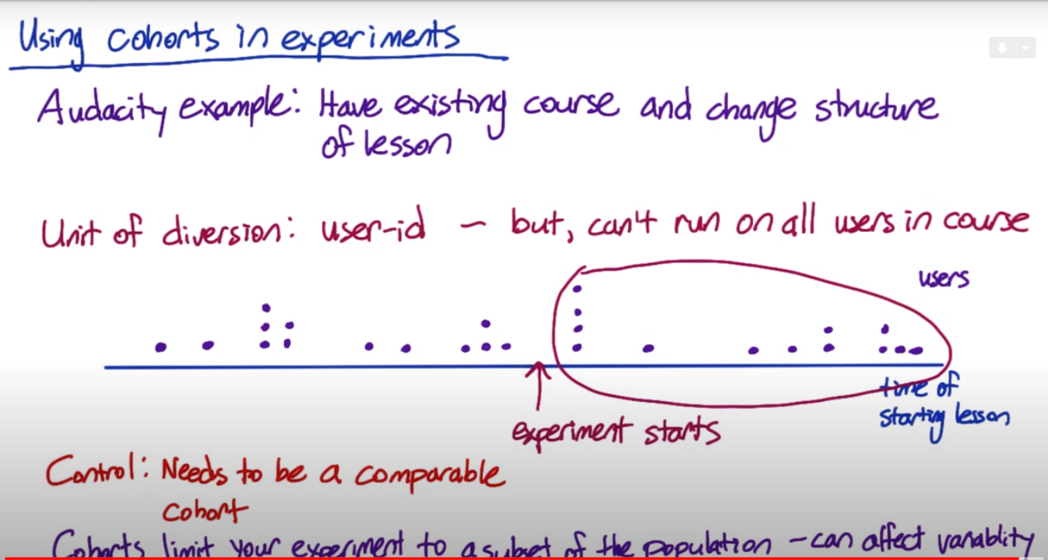

## Sizing

Although the power analysis has been discussed in Lesson 1, it provides the analytical solution. If in an experiment the unit of diversion is different from the unit of analysis, the analytical variance would underestimate the empirical variance. Thus, the sample size would be larger (even 4 times larger based on Google’s paper).

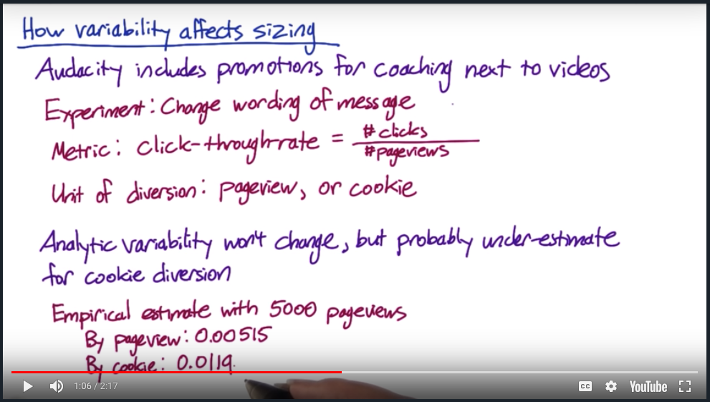

Analytic variability underestimate for cookie diversion. For example, 5000 pageviews in each group to estimate the empirical variance. Randomly sample pageviews by pageview to simulate a unit-of-diversion being pageview to to estimate the variance. Randomly sample pageviews by cookie to simulate the unit-of-diverison being cookie.



As a result, the sample size for cookie diversion is significantly larger than the one for event diversion.

As the standard error from cookie-based diversion cannot be directly calculated by the analytic formula, the above figure can be used to find the empirical SE. There are a few ways to reduce the sample of an experiment as follows.

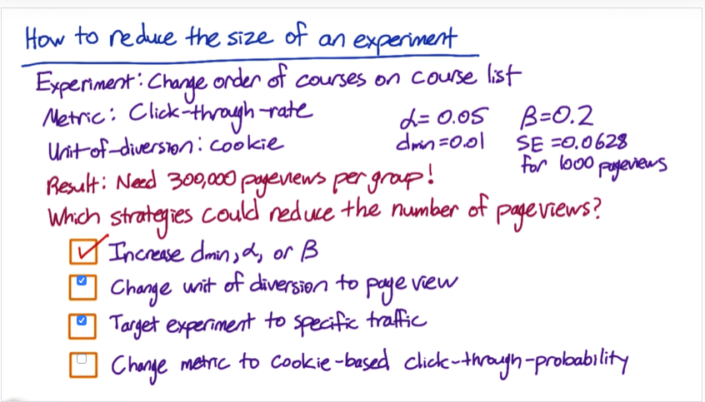

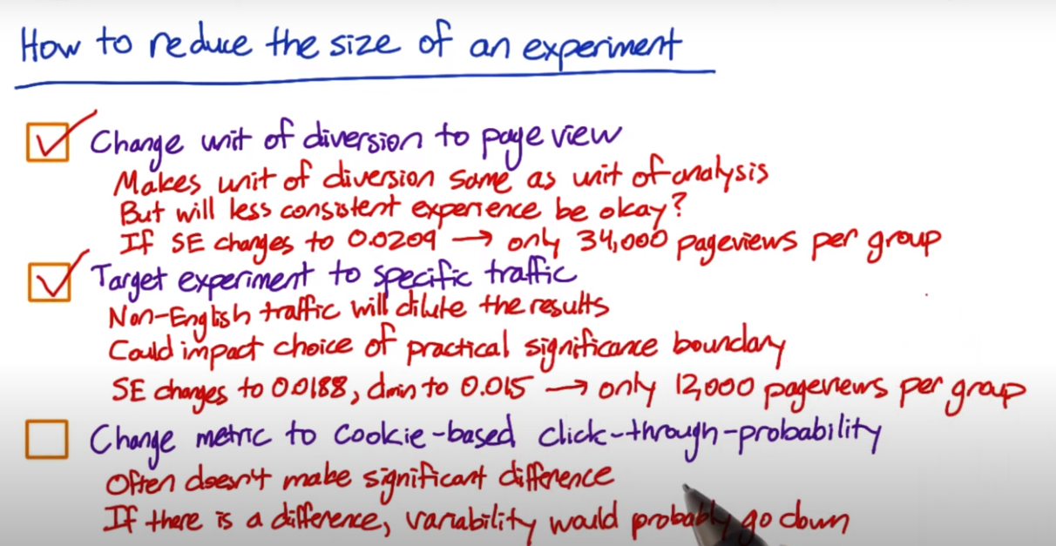

The strategies to reduce the size of an experiment.

Increase the effect size or the error (Type I or Type II) can surely reduce the size. Using the proper unit of diversion can reduce the variability and reduce the size. “Targeting experiment to specific traffic” is an interesting one. For example, only targeting the experiment to English traffic. Because the non-English traffic is not affected, including it may **dilute the results of the experiment** (reduce the effect in the experiment group) and result in increasing the size. It could also impact the choice of practical significance boundary so that a bigger change matters for the business (increase the effect size). And the variability will probably go down, it can reduce the size or target smaller changes.

Changing the metric from a click-through-rate to a click-through-probability is likely to not make a significant difference. If it does though, it would reduce the number of page views needed because the unit of diversion being user-based matches the unit of analysis and the variability will go down.

## Duration vs. Exposure

If the size of experiment is calculated, the next step is to think about duration-how long to run the experiment, and exposure-what percentage of the traffic will be included for the experiments. Based on the averaged traffic per day, one also needs to consider how long the experiment will be run. Consider longer duration in order to reduce the effect of specific days or seasonality effect. Plot the data over time to understand the seasonality or periotic pattern. If the change is highly risky, one may expose it to only a subset of the traffic, which means running the experiment for a longer time.

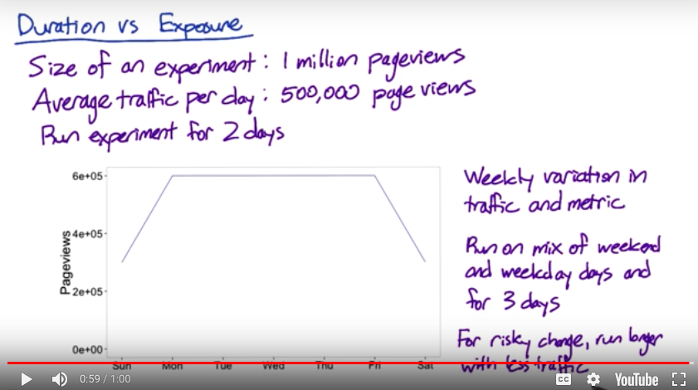

Things that need to be considered for duration and exposure

## 

## Learning Effects

The learning effect includes change a version and novelty effect.Over time either of the two effects will converge to a plateau behavior. The key issue to measure a learning effect is **time**. It takes time to adapt to a change but often times you don’t have that much time to make a decision. If time is not a problem, a few other things need to be considered when measuring the learning effects:

* Choosing the unit of diversion correctly. Need a stateful unit of diversion like a cookie or a user ID.
* The learning is not just based on time (duration)but how often they see the change — dosage. So better choose a cohort in both control and experiment based on how long the cohort’ve been exposed to the change or how many times they’ve seen it.
* Risk and duration. Don’t want to put a lot of users through a change that is being tested for a long time because it may test other changes. And it is probably a high-risk change. So better run it through a small proportion of users for a longer period of time.
* **Pre-periods and post-periods**: both pre-periods and post-periods are uniformity trials, A/A test. Before you run your A/B test on your experiment and control, it is an A/A test on a pre-period and on the exact same populations, they receive the exact treatments. In the pre-period, the difference measured between control and experiment is due to something else, such as system variability or user variability. (useful not just for measuring user learning). In the post-period, run another A/A test after A/B test ??? what is A versus A now? any result from the A/B test? then the change is due to the learning effect during that time. ???

## Summary

Choose proper unit of diversion and unit of analysis. If they are not consistent, the analytical variability may underestimate the empirical variability. As a result, the sample size may increase. Targeting the proper cohort may reduce the size. To run the experiment, the duration of the experiment and the exposure of traffic need to be considered.

## Some thoughts:

[This article](https://zhuanlan.zhihu.com/p/38471891) from Zhihu analyzes an interview question for A/B testing from Facebook. The question is that how to perform A/B testing when we choose the user-based **unit of diversion** and the users in A and B groups have **network effect**. The network effect means, for example, the users in the two groups may be not **independent** (e.g. they may know each other) so their behavior may have correlations. Thus, the difference between the two groups may be underestimated or overestimated. How to reduce the network effect in order to have more accurate results from A/B testing?

[This follow-up article](https://zhuanlan.zhihu.com/p/38717093) gives one approach, **difference in difference**, with 5steps:

* Find two groups of users that don’t know each other. A common and reliable way is to choose users from different locations to reduce the network effect. (reducing network effect)
* Before running the experiment, measure the metrics as an evaluation of the default behaviors or baseline of the two groups of users.
* Perform the experiment and measure the metrics again.
* Calculate the difference before and after the experiment for each of the two groups. This difference eliminates the different of their default behaviors. What may cause the difference, the change or just the time? (reducing the effect due to different users themselves)
* Calculate the difference of the difference from step 4 between the two groups. Now the final difference represents the difference caused by the change. (this is the real effect from the change)

This idea is similar to the review paper about propensity score I read before. I should read more about [Causal inference](https://cosx.org/2012/04/causality4-observational-study-ignorability-and-propensity-score/).

**4 Analyzing Results**

4.1 Sanity Tests

One of the first things to do once you finish collecting experimental data is to analyze the invariants. This is done by calculating the values for one or more invariants on the test and control group, and check if the difference is statistically significant. For e.g. if the values for an invariant (say total # of cookies) are x and y, then calculate the sese as 0.5∗0.5x+y−−−−−√0.5∗0.5x+y, since one would expect the same number of cookies in both groups. Then calculate the margin as 1.96∗se1.96∗se. If the margin is greater than x/(x+y)−y/(x+y)x/(x+y)−y/(x+y), then the difference of the invariant is insignificant. However if the difference is greater than the margin, then the difference is insignifiant and needs to be investigated further

An example is provided below:

control_event_ct = c(2451,2475,2394,2482,2374,1704,1468)

test_event_ct = c(2404,2507,2376,2444,2504,1612,1465)

control_total = sum(control_event_ct)

test_total= sum(test_event_ct)

p_cont = control_total/(control_total+test_total)

p_test = test_total/(control_total + test_total)

p_cont

## [1] 0.5005871

p_test

## [1] 0.4994129

se = sqrt(0.5*0.5/(control_total+test_total))

margin = 1.96*se

p_cf_min = 0.5 - margin

p_cf_max = 0.5 + margin

p_cf_min

## [1] 0.4944032

p_cf_max

## [1] 0.5055968

The most common reasons for sanity checks failing is data capture. Other reasons could be experimental set-up, for e.g., where there is a filter on the test but not on the control

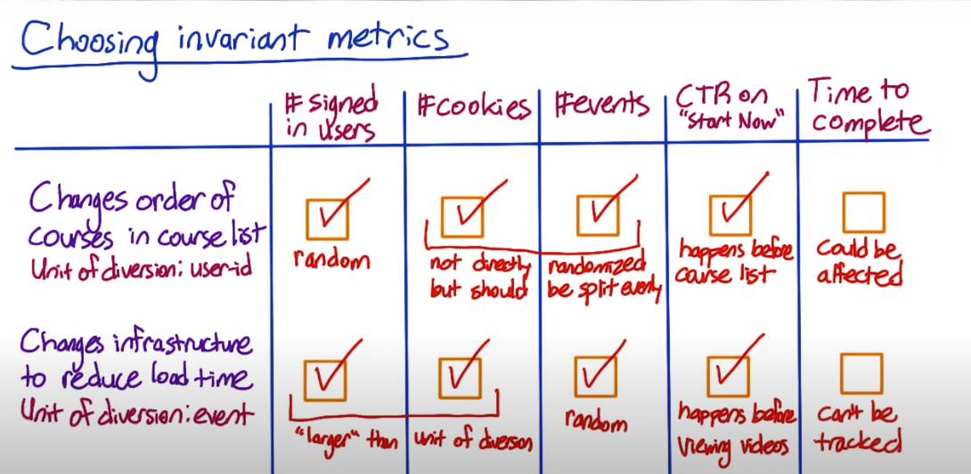

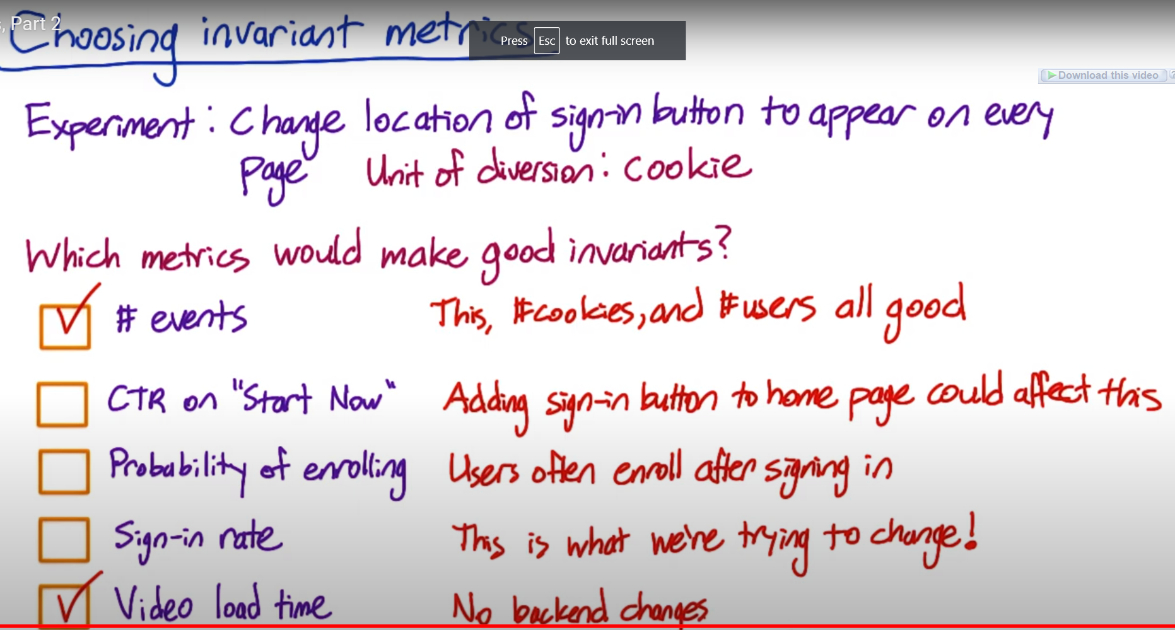

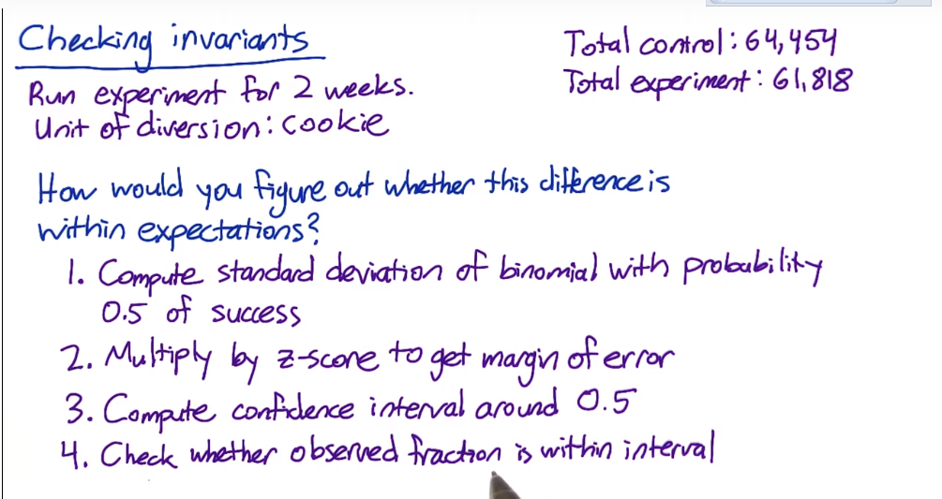

4.2 Analysis with a Single Metric

*# Data provided from test*

Xs_cont = c(196, 200, 200, 216, 212, 185, 225, 187, 205, 211, 192, 196, 223, 192)

Ns_cont = c(2029, 1991, 1951, 1985, 1973, 2021, 2041, 1980, 1951, 1988, 1977, 2019, 2035, 2007)

Xs_exp = c(179, 208, 205, 175, 191, 291, 278, 216, 225, 207, 205, 200, 297, 299)

Ns_exp = c(1971, 2009, 2049, 2015, 2027, 1979, 1959, 2020, 2049, 2012, 2023, 1981, 1965, 1993)

Xs_cont_sum = sum(Xs_cont)

Ns_cont_sum = sum(Ns_cont)

Xs_exp_sum = sum(Xs_exp)

Ns_exp_sum = sum(Ns_exp)

p_cont = Xs_cont_sum/Ns_cont_sum

p_exp = Xs_exp_sum/Ns_exp_sum

*# Empirical standard error and count provided*

empirical_se = 0.0062

empirical_ct = 5000

se = (sqrt(1/Ns_cont_sum + 1/Ns_exp_sum))*empirical_se/sqrt(1/empirical_ct + 1/empirical_ct)

*# Calculating the cf for the difference*

d = p_exp-p_cont

margin = se*1.96

d_c95min = d - margin

d_c95max = d + margin

*# Sign test*

diff_sign = Xs_exp/Ns_exp - Xs_cont/Ns_cont

pos_diff = sum()

One thing to be wary of is **Simpson’s paradox,** where the effect in aggregate may indicate one trend, and at a granular level may show an opposite trend.

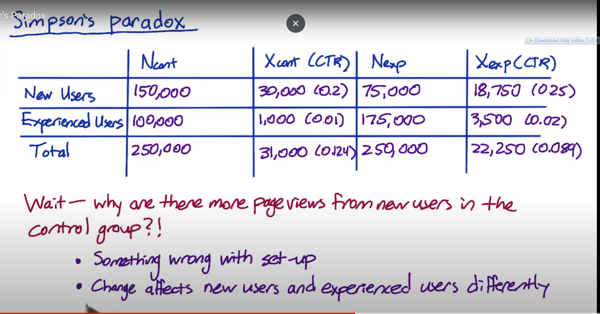

4.3 Multiple checks

The more things you test, the more likely you are to see significant difference just by chance. This is a problem, but since it is not repeatable for the same metric across multiple attempts, there is a way out. One can do multiple runs of the experiment, or alternately bootstrap. There is another technique called multiple comparison that adjusts your significance levels that accounts for how many metrics or tests you are doing.

For e.g. if you had 10 metrics where you used a 95% confidence interval for each metric, what is the probability that one of the metrics will show up as a false positive?

p1 = 0.99

p_nofp = p1^10

p_fp = 1-p_nofp

p_fp

## [1] 0.09561792

As you increase the number of metrics, you can use a higher confidence level to overcome false positives.

A different method used in practice is Bonferroni correction. It has the advantages of being simple, makes no assumptions, and guaranteed to give αoverallαoverall as low as you have specified.

To use it, calculate

αindividual=αoverallnαindividual=αoveralln

For e.g. if you want αoverallαoverall to be 0.05 and there are 5 metrics then αindividualαindividual will be 0.05/3=0.016660.05/3=0.01666

Bonferroni methods may be very conservative. Alternatives include [closed testing procedure](https://en.wikipedia.org/wiki/Closed_testing_procedure), [Boole-Bonferroni bound](https://en.wikipedia.org/wiki/Boole%27s_inequality) and [Holm-Bonferroni method](https://en.wikipedia.org/wiki/Holm%E2%80%93Bonferroni_method). The αoverallαoverall above is often referred to as the familywise error rate (FWER). Another measure is the [contol false discovery rate](https://en.wikipedia.org/wiki/False_discovery_rate) (FDR) defined as the (# false positives)/(#rejections). CDR makes sense if you have a large number (200) metrics.

An alternative to using multiple metrics is to use an ‘Overall Evaluation Criterion’ (OEC).

4.4 Gotchas

Effect may ramp out as you implement the change. There could be seasonal effects. For e.g. students on summer break have very different behavior than when they come back. Similarly during black friday and other holidays. One of the ways is to leave a small sample out as a hold-out to track them over time.

**5 Summary**

* Decision to launch change should be guided by business reasons and not just
* Opportunity cost of launching the change (engineering costs, user experience), based on not launching it

**6 References**

1. [Additional Techniques for Brainstorming and Validating Metrics](https://storage.googleapis.com/supplemental_media/udacityu/3954679115/additional_techniques.pdf?GoogleAccessId=1069728276824-fdhtlb98k1m9qrmdgj4jgc7gjp2l1lsm@developer.gserviceaccount.com&Expires=1438057124&Signature=aisqm5m1VJX0%2Bk6ZKBlSAm6JxjzRbOVmr%2BGey%2BkDtTVYL%2BJzfI133AG%2BsnTFhmrr/b9xOWsf/6oBY%2B0Fy6WRanrBICYKMkJ/xpXroG1zSdp39GzHYpzA30H7btkoWMheAbmHqVS36gaWmr4PXyW9dNPKK2tq/QnJT04vnkjMsgU%3D)
2. [Comparing 2 populations: Binomial and Poisson](http://www.stat.wisc.edu/~wardrop/courses/371chapter9b.pdf)
3. [Tests for Two Poisson Means](http://ncss.wpengine.netdna-cdn.com/wp-content/themes/ncss/pdf/Procedures/PASS/Tests_for_Two_Poisson_Means.pdf)
4. [Final Project Template](https://docs.google.com/document/d/16OX2KDSHI9mSCriyGIATpRGscIW2JmByMd0ITqKYvNg/edit)
5. [Large Scale Validation and Analysis of Interleaved Search Evaluation](http://www.cs.cornell.edu/People/tj/publications/chapelle_etal_12a.pdf)
6. [Overlapping Experimental Infrastructure: More, Better, Faster Experimentation](http://static.googleusercontent.com/media/research.google.com/en/us/pubs/archive/36500.pdf)

**7 Glossary**

*change aversion*: users averse to change reduce usage

*interleaved experiment*: an experiment in which you expose the same user to both A and B at the same time

*interuser experiment*: an experiment in which you expose users to either A or B.

*intra-user experiment*: is where you expose the same user to an experiment being on and of at different times.

*novelty effect*: users see something new and test out everything

*retrospective analysis*: look at historical data, observe changes, and conduct an evaluation

*userflow*: Shows the flow of users through the site, often referred to as a customer funnel.